Calm Chore
Product Requirements Document
Prepared for parent focus group review · Draft v1

1. Introduction
Calm Chore is a mobile-friendly app that turns everyday household chores into a motivating, gamified routine for kids, while keeping parents fully in control. Parents create the family's chores, assign or open them up for kids to choose, review and approve completed work, and manage how earned points get redeemed for real rewards. Kids see their chores on a calendar, submit proof of completion, build a day-by-day streak, and compare progress with friends.
The name and visual design are intentionally low-pressure — the goal is a calm, encouraging routine, not a stressful task list. This document summarizes what the app does, screen by screen, so the focus group can react to the overall shape of the product before it's built.

2. Who Uses the App

Parents
Parents create the family account and can invite a second parent to share admin duties. A parent adds each child's profile, defines chores and their point values, reviews submitted chores, manages point redemption requests, and can pause chore expectations for planned absences.

Children
Each child logs in with a username and passcode set up by a parent (no email needed). Kids pick a nickname and a colour the first time they log in. From there, they browse and accept chores, submit proof of completion, track their points and streak, redeem points for rewards, and connect with friends.

3. A Typical Week
A parent sets up “Empty the dishwasher” as a daily chore worth 10 points, assigned to both kids, requiring a photo. Each morning it shows up on each child's calendar and chore list. A child does the dishwasher, takes a photo, and taps Submit for Verification. That evening, a parent reviews the photo in Validate Chores and marks it Verified Complete — 10 points land in the child's account and their streak ticks up by a day.
Later in the week, one child knows they'll be away at a sleepover and won't be able to do chores that day, so they apply their weekly Chore Freeze in advance to protect their streak. The family then leaves for a long weekend trip, so a parent sets a Chore Break covering both kids for those dates — no chores are expected, and everyone's streak simply holds in place until they're back.
Over the following weeks, a child's streak carries them from Rook up through Warrior and into Hero tier, their shield gaining a new weapon at each sub-level. They spend some of their points on 45 minutes of extra screen time (a parent approves the request and enters the point cost), and they connect with a cousin from another family as a friend to compare streaks on a shared leaderboard.

4. Feature Details

4.1 Accounts & Profiles
The app's opening screen offers separate Parent and Child sign-in paths. A parent creates an account with their name and email, then can:
- Invite additional parents (name and email) who can also manage the same children
- Add a profile for each child: name, a username that must be unique across the whole app, and a 6-digit passcode
On first login, a child sets their own nickname (also unique app-wide, since it's used for friend search) and picks a personal accent colour from a curated set (blue, red, purple, orange, gold, teal — no two children on the same account can pick the same one). That colour follows the child everywhere: the chore calendar, header accents, and badges throughout their own login. Parents keep a fixed, calming green theme rather than choosing a colour. A parent can reset a child's passcode at any time from Setup.

4.2 Notifications
Parents choose, action by action — new chore, chore assignment, deadline changes, chore accepted, chore completion, review outcome, points awarded, points redeemed, friend requests, and more — whether they and their children are notified in-app, by email, or both. Children only receive in-app notifications.

4.3 Creating & Scheduling Chores
A parent defines a chore's name, description, point value, whether a photo is required to prove completion, and whether it repeats (daily, weekly, monthly, or a custom schedule) with an end date or a set number of occurrences.
- To help set a fair point value, the parent can answer “about how long does this feel like it takes?” on a simple scale (5 to 60+ minutes), and the Points field pre-fills with a suggested value (roughly 1 point per 10 minutes, minimum 1). It's only a starting suggestion — the parent can freely change it.
- A chore can be assigned to one specific child, to several children (each doing it independently), or left open for any child to pick up
- Parents can adjust the schedule, points, or assignment for an individual occurrence without changing the chore's overall definition
- A "Chore Ideas" library lets parents browse chore names and descriptions other families have created, as a source of best-practice inspiration — no child information or photos are shared. It ships pre-seeded with an age-banded starter list (2-3, 4-6, 7-11, 12+ years) so there's something to start from immediately, each with a suggested time estimate and points value using the same 1-point-per-10-minutes logic

4.4 Doing & Verifying Chores
Kids see chores on a colour-coded calendar and in a personal chore list split into Ongoing and Completed. Open chores can be accepted; assigned chores appear automatically. When a chore requires proof, the child takes a live photo (camera only, not the photo gallery, so old photos can't be reused) and submits it for review.
- A parent reviews each submission and marks it Complete, Partially Complete (entering an adjusted point award), or Incomplete (entering a reason the child can see), using three simple face-icon buttons (happy / neutral / sad) with the label always shown alongside, so the outcome reads at a glance
- An Incomplete chore returns to the child’s list so it can be redone and resubmitted
- That same face-icon treatment carries through wherever a child sees the outcome of a chore (their chore list, the chore detail popup), replacing wordier status text with something quicker for kids to read

4.5 Points, Streaks & Tiers
Completed chores earn points, shown alongside a running history of credits and debits. Doing at least one chore a day builds a streak. Every 7 days of streak advances a themed tier — Rook, Warrior, Hero, Champion, Icon, Legend, Master, Sovereign, Titan, Oracle, Avatar, Demigod, with further tiers added for exceptionally long streaks. Each tier is shown as a knight's shield that grows more colourful and ornate at higher tiers, and each tier has 3 internal levels shown by the number of weapons displayed on the shield.
- Weekly Streak Bonus: completing a full calendar week (Mon-Sun, every required day covered by a chore, a freeze, or a Chore Break) earns a one-time bonus of 10% of that week's total earned points (rounded, minimum 1), posted as its own Points History line rather than changing any chore's own point value. A child who joins mid-week only needs their days from then through Sunday covered for that first week to count.

4.6 Chore Freezes & Chore Breaks
Two related safety nets protect a streak without requiring chores to be done every single day:
- Chore Freeze: protects a streak on a day with no completed chores. The first such day each week (Rook-Legend tiers) or first two days (Master tier and above) apply automatically — no request needed — and a banner tells the child afterward which day was covered. Unused free freezes don't carry over to the next week, and a day with no chores available at all doesn't use one up.
- Multi-day Freeze Request: for longer stretches (exams, travel, a busy sports week) or for freeze needs beyond the free weekly count, a child can request a date range with a reason. This requires a parent's approval, and draws on the weekly freeze allowance from each week the request spans.
- Chore Break: a parent-initiated date range covering one, several, or all children — for planned absences like a family trip — during which the streak simply holds in place and affected chore occurrences are hidden rather than counted as missed.

4.7 Redeeming Points
A child requests to redeem points under a category — Grocery Treats, Purchases, Eating Out, Screen Time, Cash / Pocket Money, or Other — describing what they'd like (eating out requests note a restaurant, cuisine, or what they're after; screen time requests also specify a duration and purpose; cash requests specify an amount). The request appears in the parent's queue, where it's approved (with the parent choosing how many points to debit, capped at the child's balance, with a confirmation step) or rejected with a reason. Both sides can see the full history of requested, approved, and rejected redemptions.
Redemption values are intentionally left to each parent's judgment rather than a fixed price list — consistent with how most families already handle allowance and rewards.

4.8 Friends & Leaderboard
A child can search for another child by nickname only (not their real name, so a child can't be located by someone who isn't already an intended contact) and send a friend request. The request must be approved by the other child's own parent before the connection is made; the requesting child sees a Pending status in the meantime. Connected friends can see each other's name, nickname, streak, points, tier, and the names, dates, and points of their five most recent completed chores — never proof photos, which stay visible only within a child's own family. Either child can remove the friendship at any time, no approval needed on either side.

4.9 Feedback & Help
Both parents and kids can submit feedback on bugs or feature ideas, visible to parents with the submitter's role clearly marked. An in-app About section walks each type of user through how to use the app in plain language.

4.10 Parent-Managed Chores (for younger kids)
Not every child is ready for their own device or passcode. A child's profile can be flagged Parent-Managed instead of given a username and passcode — the parent then tracks that child's chores from a dedicated “Manage for Child” tab in their own login, rather than the child logging in themselves. If a parent has more than one Parent-Managed child, the tab opens with a simple child selector.
- The multi-step child flow (accept, do, submit proof, await validation) collapses into one action: the parent taps "Mark Done," takes a live photo if required, and rates the outcome immediately with the same face-icon buttons used elsewhere — points and streak update right away
- Chore Freezes and points redemption also skip their usual request step, since there's no separate child to request from — the parent applies a freeze or adjusts points directly on the child's behalf
- Friends and the leaderboard stay off for Parent-Managed children for now, since that assumes independent interaction the child isn’t yet doing
- The flag can be switched off later, once a child is ready for their own login — their points, streak, and tier history carries over unchanged

4.11 Adding the App to Your Home Screen
The first time the app is opened on a given device, whether by a parent or a child, it prompts the user to add it to their home screen. On Android and other Chromium-based browsers this is a genuine one-tap install button; on iPhone (Safari doesn't allow a website to trigger installation directly) it's a short visual walkthrough pointing to the Share button. The prompt can be dismissed and isn't a one-time miss — it can resurface on a later login if the app still isn't installed. Step-by-step instructions also live permanently in each login's About section.

4.12 Privacy & Data Handling
Because Friends connects children across different families, Calm Chore handles children's personal data beyond a single household, not just within one family's own devices — the following baseline applies regardless of how many families use it:
- Every child profile is created by a parent, not self-registered by the child — this is the structural basis for parental consent, paired with an explicit privacy notice shown during parent account creation
- What a connected friend (a different family) can see is limited to: name, nickname, streak, points, tier, and the last 5 completed chore names with date and points — nothing else
- What is never shared outside a child's own family: proof photos, passcodes, email addresses, notification settings, and full chore or redemption history beyond that last-5 summary
- A parent can request deletion of a child's profile and its data (photos, points history, chore history), which also removes that child from any friends' connections
Note: since this can extend to children outside the immediate family, it likely falls under children's privacy regulations (e.g. COPPA in the US) once used beyond a single household. This spec sets the product-level baseline, but an actual privacy policy and legal review are still needed before any wider release.

5. Design Principles
- Mobile-first: every screen is designed and built for a phone first, not adapted from a desktop layout
- Calming visual tone: the colour palette favours nature-inspired greens, soft blues, and warm neutrals over high-alert colours, in keeping with the "Calm Chore" name
- Parent oversight by default: anything that moves points, connects children, or changes what counts as done runs through a parent approval step

6. How It All Connects
The two diagrams below walk through the app's core workflows, showing which actions belong to the parent (blue), which belong to the child (green), which happen automatically (grey), and where a decision is made (orange).

Onboarding, the chore lifecycle, and friends
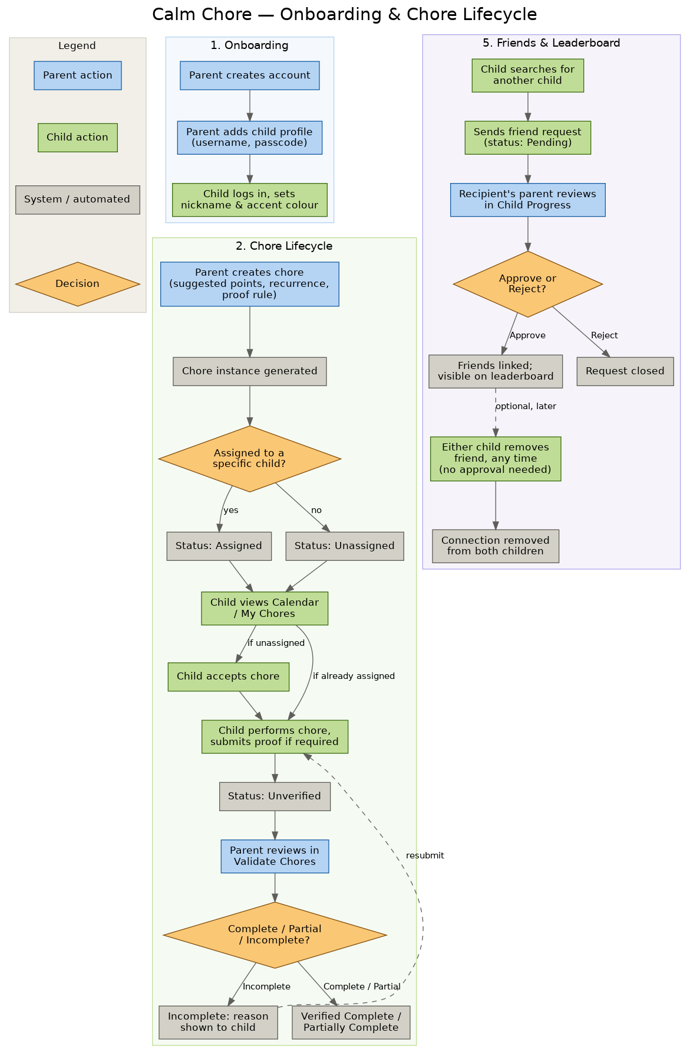

Points, streaks, and redemption
Continues from “Verified Complete / Partially Complete” at the bottom of the chore lifecycle above.
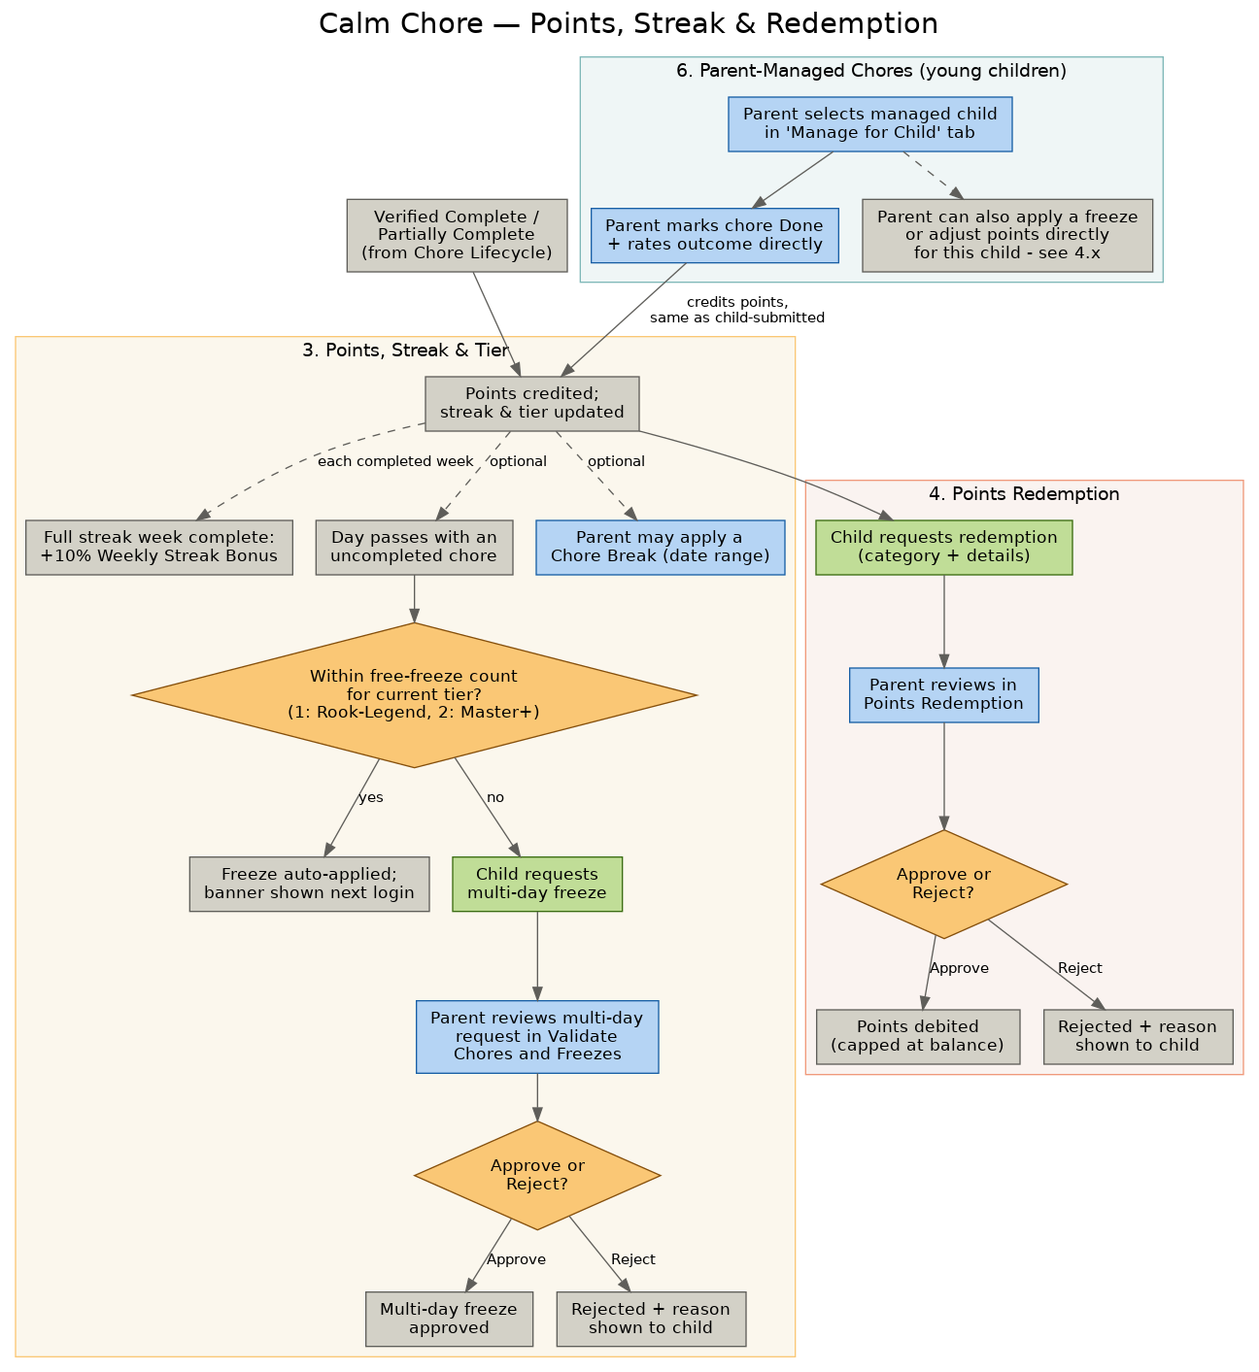

7. Glossary
Term | What it means
Chore | A task a parent defines once (name, description, points, and whether a photo is required), which can repeat on a schedule.
Occurrence | One specific scheduled happening of a chore — e.g., today's trash duty versus next Tuesday's.
Streak | The number of consecutive days a child has completed at least one chore.
Tier | A themed rank (Rook, Warrior, Hero, Champion, Icon, Legend, Master, Sovereign, Titan, Oracle, Avatar, Demigod, and beyond) reached in 7-day blocks of streak, shown as an increasingly decorated knight shield.
Level | A sub-stage within a tier (1 to 3), shown by the number of weapons on the shield.
Chore Freeze | Protects a streak on a day with no completed chores. 1 (or 2, at higher tiers) apply automatically each week; more requires parent-approved request.
Weekly Streak Bonus | A one-time 10% bonus on a week's earned points, credited when a full streak week completes without breaking.
Chore Break | A date range a parent sets — e.g., a family trip — that pauses chore expectations and protects the streak for one, several, or all children.
Verified Complete / Partially Complete / Incomplete | The outcome a parent selects after reviewing a submitted chore, which determines the points awarded.
Redemption request | A child's ask to trade points for a real-world reward, which a parent approves (debiting points) or rejects.
Parent-Managed child | A child profile without its own username/passcode, for kids too young for their own device — the parent tracks chores, points, and rewards on their behalf from a 'Manage for Child' tab.

8. Questions for the Focus Group
A few things we'd especially value your reaction to:
- Do the redemption categories (Grocery Treats, Purchases, Eating Out, Screen Time, Cash / Pocket Money, Other) cover what your family would actually use, or is something missing?
- Does 1 free Chore Freeze per week (2 at higher tiers), an approvable multi-day freeze for longer stretches, plus parent-set Chore Breaks for trips, feel like the right amount of flexibility — too much, too little, or about right, including for older kids and teens?
- How do you feel about kids being able to search for and request other children by nickname across the app, given a connection only completes once you approve it?
- Now that Friends shares some progress info across different families, does what's visible to a connected friend (name, streak, points, tier, last 5 chore names) feel like the right amount, or would you want less shared by default?
- Do the tier names and 7-day pacing feel motivating for your kids’ ages, or too slow / too fast?
- Any concerns about requiring a live photo as proof of a completed chore, especially for younger children?
- Is leaving redemption point-values up to each parent’s own judgement the right call, or would your family want more built-in guidance?
- For younger kids without their own device, does the Parent-Managed approach (parent tracks chores on their behalf, from their own login) feel like the right stand-in, or is there something about the usual kid experience it should still try to capture?
- Does a 10% Weekly Streak Bonus feel like a meaningful payoff for keeping a streak alive, or should it be higher / lower / structured differently?

